**Description**

This document is written on February 22, 2022 by -Myra Ophelia Iman

**WhatsApp Message from Excel using VBA and Selenum Setup Installation.**

1. Required Application
2. Selenium VBA : <https://github.com/florentbr/SeleniumBasic/releases/tag/v2.0.9.0>
3. ChromeDriver-WebDriver for Chrome

<https://chromedriver.chromium.org/downloads>

1. Microsoft Excel
2. Setup-Selenium Basic, Chromedriver
3. Install (Selenium VBA)

Navigate to Selenium VBA link and click dowload at assets SeleniumBasic-2.09.0.exe.

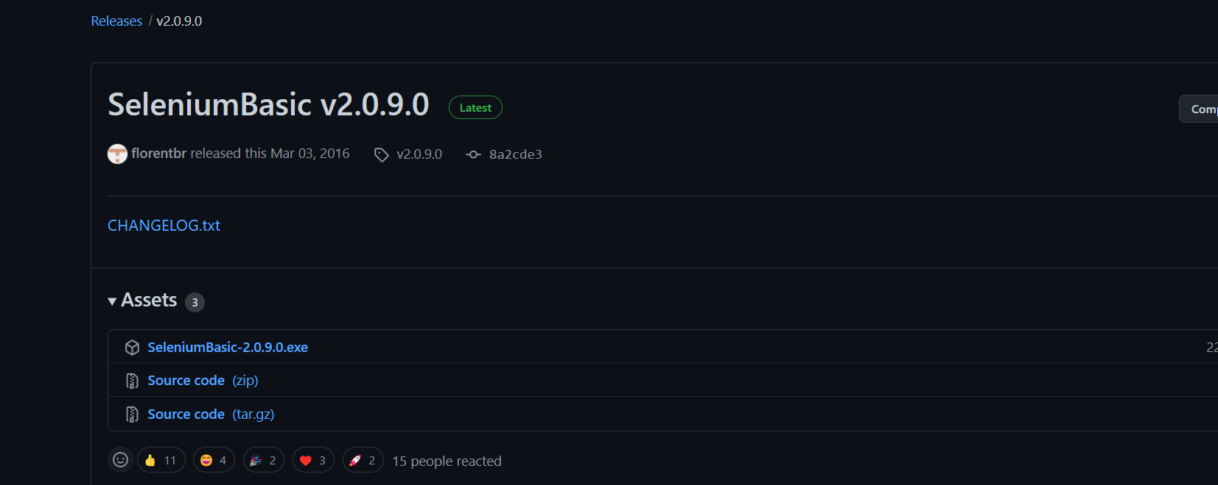

1. Run

Open up installer and keep all the default settings, keep the installation folder path. Once it done, navigate to the selenium folder in the directory.

|  |  |
| --- | --- |
|  |  |

1. Add

After navigate the directory,replace the chromedriver.exe with the matching google chrome version.

To find your chrome version, go to google navigate to help “Click About Chrome”. Copy and paste the version and search for chrome driver dowload. (Example = “Version 98.0.4758.102 chromedriver download ”)

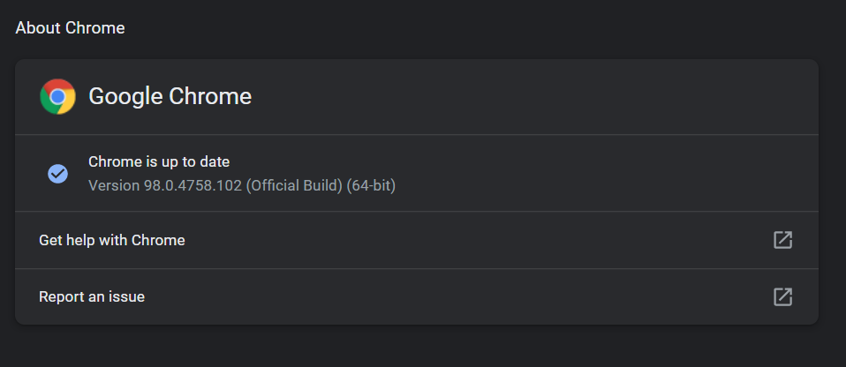

Choose the top link and click it. After that, choose the correct version of your chromedriver and click it. It will navigate to this page and click the chromedriver_win32.zip and download. Replace the chromedriver in the directory with the one just downloaded. Done with installation.

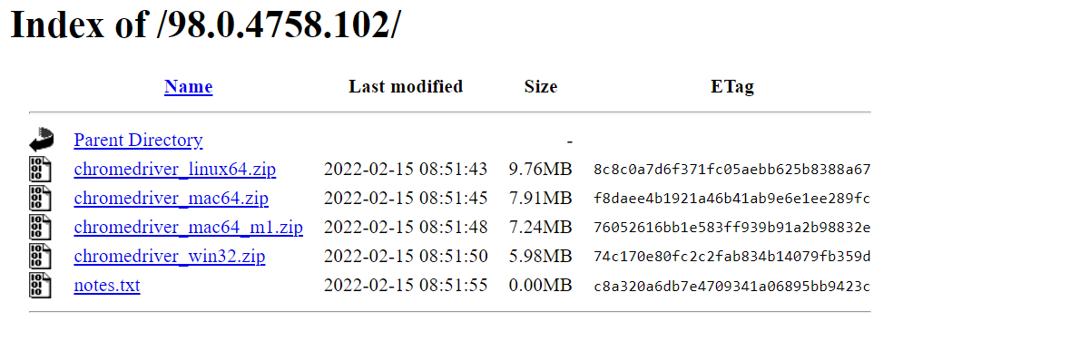

1. Setup Excel
2. Create Number, Text, Type, Image Caption, Status and apply some styling to make the excel interesting.

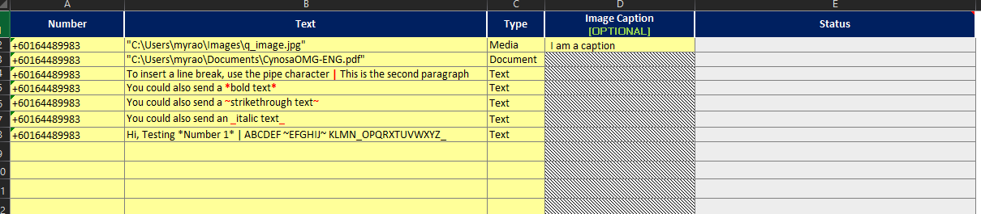

1. Vba editor

* Click on developer tab, if’s not visible please enable it under file, option and click on customize Ribbon. Please select developer checkbox and click OK.
* Click on insert tab and choose modules to start code.

1. How to send attachments

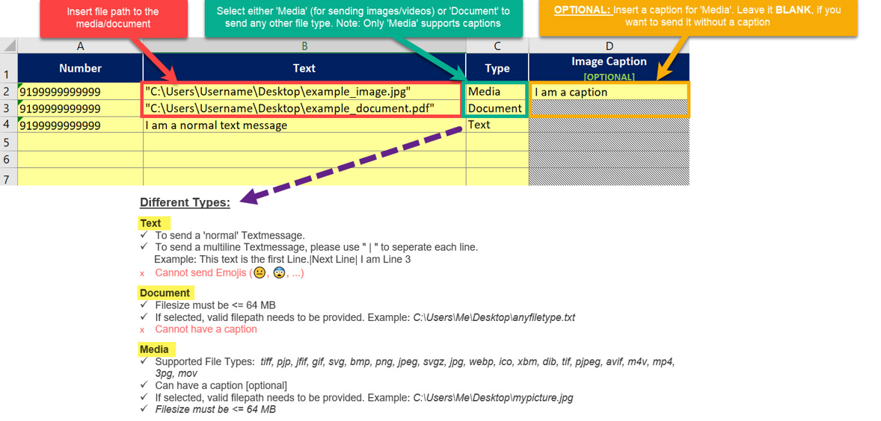

1. Test Connection
2. We can send messages through VBA with a saved number in WhatsApp.

* WhatsApp Term of Service
* <https://faq.whatsapp.com/general/security-and-privacy/unauthorized-use-of-automated-or-bulk-messaging-on-whatsapp/?lang=en>

1. Check on run button/ Run WhatsApp Bot, it will appear the website of WhatsApp.

Log in the QR code and the VBA will send all the message base on the excel.

Don’t forget to click OK button. The status show it successfully send.

|  |  |
| --- | --- |
|  |  |

1. Video Simulation

* I send all the message to myself and Zua (supervisor)

